K8s installation aws ems another Jenkins service

1. Re-download the Kubectl Binary:
It's possible that the download was incomplete or corrupted. Try re-downloading the kubectl binary:
bash
Copy
sudo rm kubectl # Remove the existing kubectl binary if any
sudo curl -LO https://dl.k8s.io/release/$(curl -L -s https://dl.k8s.io/release/stable.txt)/bin/linux/amd64/kubectl

2. Re-download the Checksum File:
It's also possible that the checksum file is outdated or corrupted. Try re-downloading it:
bash
Copy
sudo rm kubectl.sha256 # Remove the existing checksum file
sudo curl -LO https://dl.k8s.io/release/$(curl -L -s https://dl.k8s.io/release/stable.txt)/bin/linux/amd64/kubectl.sha256

3. Verify Permissions:
Check the permissions of the kubectl binary to ensure that it is readable by the user:
bash
Copy
ls -l kubectl

If it’s not executable, you can make it executable with:
bash
Copy
sudo chmod +x kubectl

4. Run the Checksum Verification Again:
Once you have re-downloaded both the binary and the checksum file, try verifying the checksum again:
bash
Copy
echo "$(cat kubectl.sha256) kubectl" | sha256sum --check
If everything is correct, you should see an output like:
makefile
Copy
kubectl: OK

=======================
================================
=========================================
==============================================
======================================================
=============================================================
=====================================================================
===========================================================================
Kubectl installation,

sudo install -o root -g root -m 0755 kubectl /usr/local/bin/kubectl

- Test to ensure the version you installed is up-to-date:
Sudo kubectl version --client

Or use this for detailed view of version:
kubectl version --client --output=yaml

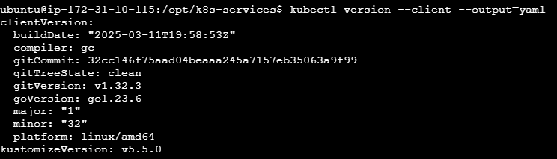
======================
============================
===================================
============================================
=====================================================
===============================================================
=========================================================================
==================================================================================
sudo apt-get update
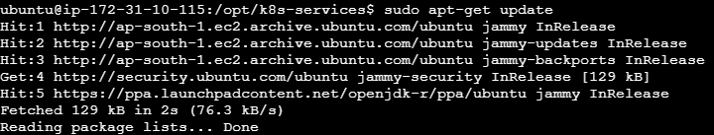

Install using native package management
- Debian-based distributions
- Red Hat-based distributions
- SUSE-based distributions
- Update the apt package index and install packages needed to use the Kubernetes apt repository:
- sudo apt-get update
- # apt-transport-https may be a dummy package; if so, you can skip that package
- sudo apt-get install -y apt-transport-https ca-certificates curl gnupg
- Download the public signing key for the Kubernetes package repositories. The same signing key is used for all repositories so you can disregard the version in the URL:
- # If the folder `/etc/apt/keyrings` does not exist, it should be created before the curl command, read the note below.
- # sudo mkdir -p -m 755 /etc/apt/keyrings
- curl -fsSL https://pkgs.k8s.io/core:/stable:/v1.32/deb/Release.key | sudo gpg --dearmor -o /etc/apt/keyrings/kubernetes-apt-keyring.gpg
sudo chmod 644 /etc/apt/keyrings/kubernetes-apt-keyring.gpg # allow unp

=======================
============================
=====================================
===============================================
=======================================================
==============================================================
=====================================================================
============================================================================
==================================================================================

- Add the appropriate Kubernetes apt repository. If you want to use Kubernetes version different than v1.32, replace v1.32 with the desired minor version in the command below:
- # This overwrites any existing configuration in /etc/apt/sources.list.d/kubernetes.list
- echo 'deb [signed-by=/etc/apt/keyrings/kubernetes-apt-keyring.gpg] https://pkgs.k8s.io/core:/stable:/v1.32/deb/ /' | sudo tee /etc/apt/sources.list.d/kubernetes.list
- sudo chmod 644 /etc/apt/sources.list.d/kubernetes.list # helps tools such as command-not-found to work correctly

